SCHEDULE C – FORM OF PROPOSAL

RFP Project Title: Adult Hockey League Operation

RFP Reference No.: 1220-030-2024-007

Legal Name of Proponent:

Contact Person and Title:

Business Address:

Business Telephone:

Business Fax:

Business E-Mail Address:

TO:

City of Surrey

City Representative: Sunny Kaila, Manager, Procurement Services

E-mail for PDF Files: purchasing@surrey.ca

Dear Sir:

- I/We, the undersigned duly authorized representative of the Proponent, having received and carefully reviewed all of the Proposal documents, including the RFP and any issued addenda posted on the City Website and BC Bid Website, and having full knowledge of the Site, and having fully informed ourselves as to the intent, difficulties, facilities and local conditions attendant to performing the Services, submit this Proposal in response to the RFP.

- I/We confirm that the following schedules are attached to and form a part of this Proposal:

Schedule C-1 – Statement of Departures;
Schedule C-2 – Proponent’s Experience, Reputation and Resources;
Schedule C-3 – Proponent’s Technical Proposal (Services);
Schedule C-4 – Proponent's Technical Proposal (Time Schedule); and
Schedule C-5 – Proponent’s Financial Proposal.

3.0 I/We confirm that this proposal is accurate and true to best of my/our knowledge.

4.0 I/We confirm that, if I/we am/are awarded a contract, I/we will at all times be the “prime contractor” as provided by the Worker's Compensation Act (British Columbia) with respect to the Services. I/we further confirm that if I/we become aware that another consultant at the place(s) of the Services has been designated as the “prime contractor”, I/we will notify the City immediately, and I/we will indemnify and hold the City harmless against any claims, demands, losses, damages, costs, liabilities or expenses suffered by the City in connection with any failure to so notify the City.

This Proposal is submitted this [day] day of [month], [year].

I/We have the authority to bind the Proponent.

________________________________________  (Legal Name of Proponent)  _________________________________________  (Signature of Authorized Signatory)  _________________________________________  (Print Name and Position of Authorized Signatory) | ________________________________________  (Signature of Authorized Signatory)  ________________________________________  (Print Name and Position of Authorized Signatory)

SCHEDULE C-1 - STATEMENT OF DEPARTURES

1. I/We have reviewed the proposed Contract attached to the RFP as Schedule “B”. If requested by the City, I/we would be prepared to enter into that Contract, amended by the following departures (list, if any):

Section Requested Departure(s) / Alternative(s)
______________________________________________________________________

______________________________________________________________________

2. The City of Surrey requires that the successful Proponent have the following in place before commencing the Services:
(a) Workers’ Compensation Board coverage in good standing and further, if an “Owner Operator” is involved, personal operator protection (P.O.P.) will be provided,
Workers' Compensation Registration Number ___________________________;
(b) Prime Contractor qualified coordinator is Name: _______________
and Contact Number: _________________________;
(c) Insurance coverage for the amounts required in the proposed agreement as a minimum, naming the City as additional insured and generally in compliance with the City’s sample insurance certificate form available on the City’s Website at www.surrey.ca search Consultants Certificate of Insurance;
(d) City of Surrey or Intermunicipal Business License: Number ________________;
(e) If the Consultant’s Services are subject to GST, the Consultant’s GST Number is _____________________________________; and
(f) If the Consultant is a company, the company name indicated above is registered with the Registrar of Companies in the Province of British Columbia, Canada, Incorporation Number ___________________________________.

As of the date of this Proposal, we advise that we have the ability to meet all of the above requirements except as follows (list, if any):

Section Requested Departure(s) / Alternative(s)
______________________________________________________________________

______________________________________________________________________

3. I/We offer the following alternates to improve the Services described in the RFP (list, if any):

Section Requested Departure(s) / Alternative(s)
______________________________________________________________________

______________________________________________________________________

4. The Proponent acknowledges that the departures it has requested in Sections 1, 2 and 3 of this Schedule C-1 will not form part of the Contract unless and until the City agrees to them in writing by initialling or otherwise specifically consenting in writing to be bound by any of them.

SCHEDULE C-2 - PROPONENT’S EXPERIENCE, REPUTATION AND RESOURCES

Proponents should provide information on the following (use the spaces provided and/or attach additional pages, if necessary):

- Location of primary business, branch locations, background, stability, structure of the Proponent and number of years business has been operational;

- Proponent’s relevant experience and qualifications in delivering services similar to those required by the RFP;

- Proponent’s demonstrated ability to provide the Services;

- Proponent’s equipment resources, capability and capacity, as relevant;

- Proponent’s references (name and telephone number). The City's preference is to have a minimum of three references;

- Proponent’s financial strength (with evidence such as financial statements, bank references);

- Describe any difficulties or challenges you might anticipate in providing the Services to the City and how you would plan to manage these;

- Proponents should provide information on the background and experience of all key personnel proposed to undertake the Services (use the spaces provided and/or attach additional pages, if necessary);

Key Personnel

Name:

Experience:

Dates:
Project Name:
Responsibility:

Dates:
Project Name:
Responsibility:

Project Approach – Team Roles

- Proponents should provide an outline of the resource roles and estimated effort required for this project. (use the spaces provided and/or attach additional pages, if necessary); and

Role | Name | Forecasted Project Days/Hrs.

Sub-Contractors

- Proponents should provide the following information on the background and experience of all sub-contractors proposed to undertake a portion of the Services (use the spaces provided and/or attach additional pages, if necessary).

DESCRIPTION OF SERVICES | SUB-CONTRACTORS NAME | YEARS OF WORKING WITH PROPONENT | TELEPHONE NUMBER AND EMAIL

[END OF PAGE]

SCHEDULE C-3 - PROPONENT’S TECHNICAL PROPOSAL (SERVICES)

Proponents should provide the following (use the spaces provided and/or attach additional pages, if necessary):

- a narrative that illustrates an understanding of the City’s requirements and Services;

- a description of the general approach and methodology that the Proponent would take in performing the Services including specifications and requirements;

- a narrative that illustrates how the Proponent will complete the scope of Services, manage the Services, and accomplish required objectives within the City’s schedule;

- a description of the standards to be met by the Proponent in providing the Services;

(v) additional services that can be provided, i.e., tournaments;

(vi) a description of the proposed benefits for membership;

(vii) a description of the program structure – administration / officials;

(viii) a description of playoff benefits / structure; and

(ix) a sample of the proposed structure of divisions.

[END OF PAGE]

SCHEDULE C-4 - PROPONENT’S TECHNICAL PROPOSAL (TIME SCHEDULE)

The City encourages responses that demonstrate a thorough understanding of the nature of the work and what the Proponent must do to get the work done properly. To this end, Proponents should provide an estimated project schedule, with major item descriptions and time indicating a commitment to perform the Services within the time specified (use the spaces provided and/or attach additional pages, if necessary).

ACTIVITY  (Insert Milestone Dates) | Time from Notice to Proceed in Days
 | 10 | 20 | 30 | 40 | 50 | 60 | 70 | 80 | 90 | 100
Letter of Intent
SAMPLE

[END OF PAGE]

SCHEDULE C-5 - PROPONENT’S FINANCIAL PROPOSAL

Indicate the Proponent’s proposed fee (excluding GST), and the basis of calculation (use the spaces provided and/or attach additional pages, if necessary) as follows (as applicable). Below rate(s) are to be confirmed at the time of signing of this Agreement:

Schedule of Rates:

Table 1: FALL/WINTER SEASON

The City’s goal is to book as much ice time as possible and as such its preference is to allocate a minimum of 22 ice times at 1.25hrs per ice time, per week, for 28 weeks, for a total of 770 hours for the Fall/Winter Season. Ice time must be sold at a minimum of $386.37 per hour. Proponents are to complete the following table indicating the number of hours per week and total number of weeks they can commit to:

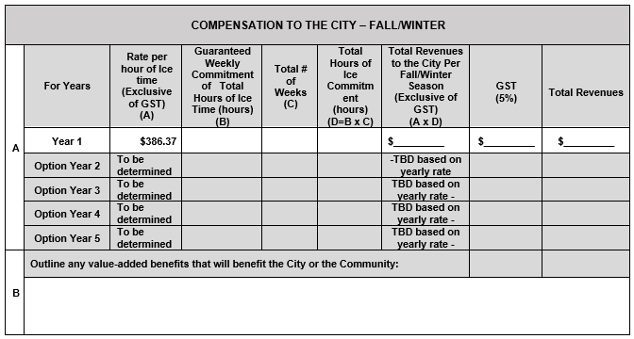

Table 2: SPRING SEASON

The City’s goal is to book as much ice time as possible and as such its preference is to allocate up to 12 weeks for the Spring Season. Ice time must be sold at a minimum of $386.37 per hour. Proponents are to complete the following table indicating the number of hours per week and total number of weeks they can commit to:

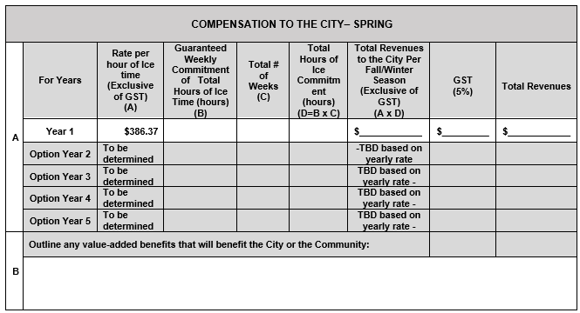

Additional Expenses:

The proposed Contract attached as Schedule "B" to the RFP provides that expenses are to be included within the fee, other than the expenses listed in the Contract as disbursements. Details of disbursements are to be shown in the chart above. Please indicate any expenses that would be payable in addition to the proposed fee and proposed disbursements set out above:

