SCHEDULE B – APPLICATION FOR A
STANDING OFFER AGREEMENT

Request For Applications For Standing Offer Agreement Title: Market Research Professional Services

Request For Standing Offer No.: 1220-060-2023-002

APPLICANT

Legal Name of Applicant:

Contact Person and Title:

Business Address:

Business Telephone:

Business Fax:

Business E-Mail Address:

CITY OF SURREY

City Representative: Sunny Kaila, Manager, Procurement Services

E-mail for PDF Files: purchasing@surrey.ca

Dear Sir:

- It is understood and agreed by the Applicant that should an Application be selected by the City, it will result in a Standing Offer only and the goods (if any) and Services will be ordered by the City solely on an “as and when required” basis. The aggregate value of the goods and Services which may be ordered is conditional upon the needs of the City. No compensation will be accrued, owed or paid to any Applicant in the event that the Services are not ordered. If a Standing Offer is executed by the City, at the sole option of the City, the City may place an Order for goods (if any) and Services specified in the Order and the Applicant agrees to provide those goods (if any) and Services. The parties agree that the City may not place any Order for Services with the Applicant for the duration of the term of the Standing Offer. The parties agree that the City may purchase identical or similar goods (if any) and Services from any other source.

- If this offer is accepted by the City, such offer and acceptance will create a Standing Offer as described in:
- the Request;
- the scope of Services set out above and in Schedule A of the Request;
- the Standing Offer Agreement as Attachment 1 to this Request;
- this Application;
- an Order (if any); and
- other terms, if any, that are agreed to by the parties in writing.

- Capitalized terms used and not defined in this Application will have the meanings given to them in the Standing Offer. Except as specifically modified by this Application, all terms, conditions, representations, warranties and covenants as set out in the Standing Offer will remain in full force and effect.

- The Applicant offers to supply to the City of Surrey, the Services for the prices plus applicable taxes as follows:

SCHEDULE OF RATES:

- Summary of Fees

(Refer to Section 2. Scope of Services of this RFA-SOA)

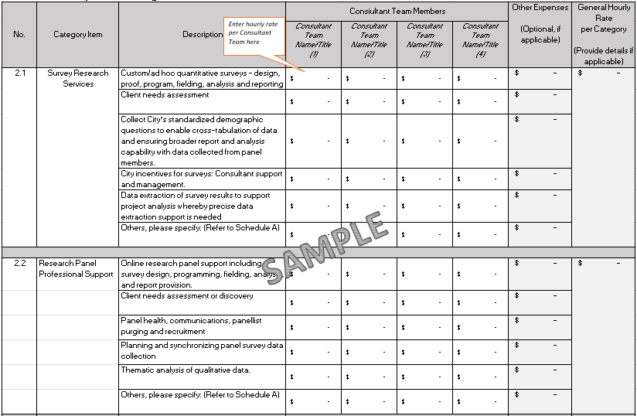

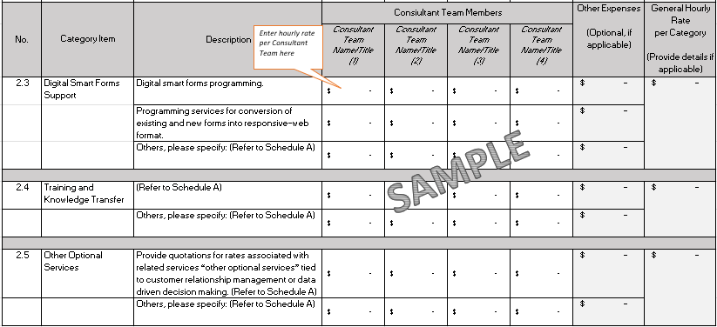

Additional Expenses:

The proposed Agreement attached as Attachment 1 to the RFA-SOA provides that expenses are to be included within the fee, other than the expenses listed in the Agreement as disbursements. Details of disbursements are to be shown in the chart above. Please indicate any expenses that would be payable in addition to the proposed fee and proposed disbursements set out above:

Experience, Reputation and Resources:

- Applicant’s relevant experience and qualifications in delivering Services similar to those required by the RFA-SOA:
______________________________________________________________________
______________________________________________________________________
______________________________________________________________________

- Applicant’s experience in developing, implementing, and managing Services as required by the RFA-SOA categories utilizing industry’s best practices. Describe if the Applicant has experience working with municipal government sector:
______________________________________________________________________
______________________________________________________________________
______________________________________________________________________

- Applicants should provide references (name and telephone number) (use the spaces The City’s preference is to have a minimum of three references and should demonstrate the ability of the Applicant to perform services similar in scope, size, nature and complexity of this RFA-SOQ. We hereby consent to the City contacting references for the purposes of evaluating our Application.
______________________________________________________________________
______________________________________________________________________
______________________________________________________________________

- Applicant should provide information on the background and experience of all key personnel proposed to provide the Services.

Key Personnel
Management and Personnel: Qualifications and relevant experience of senior management and key personnel should provide: (a) brief resume identifying each individual’s qualifications and relevant professional experience and the number of years they have worked with the Applicant; (b) list of previous project with similar to those required by the RFA-SOA.

Personnel 1:
Name/Title: ________________________________________________________________
Years of Experience [specify category(ies)]: ________________________________________________________________
Responsibilities: ________________________________________________________________
________________________________________________________________
________________________________________________________________
List Previous Projects: ________________________________________________________________
________________________________________________________________
________________________________________________________________

Personnel 2:
Name/Title: ________________________________________________________________
Years of Experience [specify category(ies)]: ________________________________________________________________
Responsibilities: ________________________________________________________________
________________________________________________________________
________________________________________________________________
List Previous Projects: ________________________________________________________________
________________________________________________________________
________________________________________________________________

Personnel 3:
Name/Title: ______________________________________________________________
Years of Experience [specify category(ies)]: ________________________________________________________________
Responsibilities: ________________________________________________________________
________________________________________________________________
________________________________________________________________
List Previous Projects: ________________________________________________________________
________________________________________________________________
________________________________________________________________

By providing this information, you warrant you have each individual’s consent to disclose their personal information in accordance with privacy laws:

- Applicants should provide the following information on the background and experience of all sub-consultants, if any, proposed to undertake a portion of the Services:

Description of Services | Sub-Contractors Name | Years of Working with Applicant | Telephone Number and Email

- Describe Applicant’s general capability and capacity to undertake the Services and provide the solution and your ability to meet the requirements of Schedule A of the RFA-SOA:
______________________________________________________________________
______________________________________________________________________
______________________________________________________________________

- Applicant should describe any resources you will acquire to undertake the Services:
______________________________________________________________________
______________________________________________________________________
______________________________________________________________________

- Applicant should describe your processes and procedures for maintaining confidentiality and security of information:
______________________________________________________________________
______________________________________________________________________
______________________________________________________________________

- Provide details of the Applicant’s professional consulting services as specified in Schedule A as they relate to each of the following categories:
  - Survey Research Services
  - Research Panel Professional Support
  - Digital Smart Forms Support
  - Training and Knowledge Transfer
  - Oher Optional Services
______________________________________________________________________
______________________________________________________________________
______________________________________________________________________

- Provide a description of the Applicant’s programs/services design and implementation and include how the Applicant proposes to integrate the components to provide complete and holistic solutions for clients:
______________________________________________________________________
______________________________________________________________________
______________________________________________________________________

- Provide a list of reports that the Applicant would anticipate providing the City’s management team, including their relationship to project milestones and the method of delivery (electronic, paper, e-mail, other:
______________________________________________________________________
______________________________________________________________________
______________________________________________________________________

- Implementation Plan:

- Provide a detailed description of the Applicant’s implementation plan and monitoring procedures that will be used to ensure that key personnel are performing to standards expected;
______________________________________________________________________
______________________________________________________________________
______________________________________________________________________

- Describe what the Applicant would use to track and improve quality of service; and
______________________________________________________________________
______________________________________________________________________
______________________________________________________________________

- Describe what management tools will be used to control project costs.
_____________________________________________________________________
______________________________________________________________________
______________________________________________________________________

- Provide a detailed work plan indicating the Applicant’s proposed project method, quality control procedures, schedule, tasks and deliverables:
______________________________________________________________________
______________________________________________________________________
______________________________________________________________________

- Environmental and Social Responsibility: Describe your commitment to environmental stewardship initiatives, recycling practices and carbon footprint reduction: Applicant should describe their capability, experience and approach on projects involving sustainability issues:
______________________________________________________________________
______________________________________________________________________
______________________________________________________________________

- Value Added Services: The Applicant should provide a description of value added, innovative ideas and unique services that the Applicant can offer to implement the City’s requirements relevant to the scope of Services described in this RFP. Unless otherwise stated, it is understood that there are no extra costs for these services.
______________________________________________________________________
______________________________________________________________________
______________________________________________________________________

- I/We have reviewed the General Terms and Conditions attached to this RFA-SOA as Attachment 1. If requested by the City, I/we would be prepared to enter into an agreement that incorporates the General Terms and Conditions, amended by the following departures (list, if any):
Section Requested Departure / Alternative(s)
__________________________________________________________________
__________________________________________________________________
__________________________________________________________________

- The City of Surrey requires that the successful Applicant have the following in place before performing the Services:

(a) Workers’ Compensation Board coverage in good standing and further, if an “Owner Operator” is involved, personal operator protection (P.O.P.) will be provided,
Workers' Compensation Registration Number ___________________________;
(b) Prime Contractor qualified coordinator is Name: _______________ and Contact Number: _________________________;
(c) Insurance coverage for the amounts required in the proposed Agreement as a minimum, naming the City as additional insured and generally in compliance with the City’s sample insurance certificate form available on the City’s Website at www.surrey.ca search Consultants Certificate of Insurance;
(d) City of Surrey or Intermunicipal Business License: Number ________________;
(e) If the Applicant’s Services are subject to GST, the Consultant’s GST Number is _____________________________________; and
(f) If the Applicant is a company, the company name indicated above is registered with the Registrar of Companies in the Province of British Columbia, Canada, Incorporation Number ___________________________________.

As of the date of this Application, we advise that we have the ability to meet all of the above requirements except as follows (list, if any):

Section Requested Departure / Alternative(s)
______________________________________________________________________
______________________________________________________________________
______________________________________________________________________

- The Applicant acknowledges that the departures it has requested in Sections 13 and 14 of this Application will not form part of the Agreement unless and until the City agrees to them in writing by initialling or otherwise specifically consenting in writing to be bound by any of them.

- I/We the undersigned duly authorized representatives of the Applicant, having received and carefully reviewed the RFA-SOA including without limitation the General Terms and Conditions, submit this Application in response to the RFA-SOA.

This Application is offered by the Applicant this _____ day of _______________, 202_.

APPLICANT

I/We have the authority to sign on behalf of the Applicant.

____________________________________  (Legal Name of Applicant)  ____________________________________  (Signature of Authorized Signatory)  ____________________________________  (Print Name and Position of Authorized  Signatory) | ____________________________________  (Signature of Authorized Signatory)  ____________________________________  (Print Name and Position of Authorized  Signatory)

